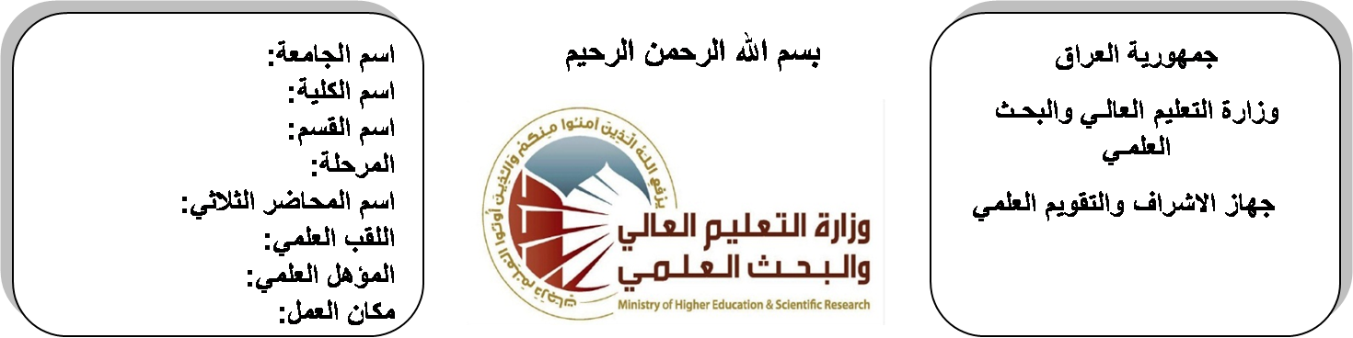

**Republic of Iraq**

**Ministry of Higher Education**

**& Scientific Research**

**University: Diyala University**

**College: College of Engineering**

**Department: Electronic Engineering**

**Stage: third**

**Lecturer name:** Khalid Awaad Humood

**Qualification: PhD**

**Place of work: Electronic Dept.**

**(( Annual teaching plan form))**

|  |  |  |  |  |
| --- | --- | --- | --- | --- |
| **Lecturer Name** | **Khalid Awaad Humood** | | | |
| **Email** | [**humoodkhalid@yah00.com**](mailto:humoodkhalid@yah00.com) | | | |
| **Subject** | Analogue Electronic II | | | |
| **Aims** | **The aim of this subject is to make the students ready to undestand and comprehend the scientific theories and their applications related to their field of the study.** | | | |
| **Textbooks** | R.boylesta “electronic devices and cicuits theory” | | | |
| **Additional Textbooks** | Electronic devices and cicuits theory by KUMAR IRBALB | | | |
| **Assessments** | **First Semester** | **Second Semester** | **Laboratory** | **Final Exam** |
| 20% | 20% | 10% | 50% |
| **Notes** |  | | | |

**Schedule Weekly Lessons - First Semester**

|  |  |  |  |  |
| --- | --- | --- | --- | --- |
| **Week** | **Date** | **Lectures** | **Lab. Experments** | **Notes** |
| 1 | **29/9/** | Frequency response characteristics |  |  |
| 2 | **5/10/** | Frequency small signal models of JFETs |  |  |
| 3 | **12/10/** | Frequency response of various amplifier configutions. |  |  |
| 4 | **19/10/** | Amplifer Frequncy Response |  |  |
| 5 | **26/10/** | Frequency response concepts, transistor at high frequency |  |  |
| 6 | **2/11/** | multistage at low &high frequency ,FET amplifiers at low &high frequency |  |  |
| 7 | **9/11/** | Freed back Amplifier |  |  |
| 8 | **16/11/** | Freedback concept, types, effects & topologies, feed back analysis, voltage-series |  |  |
| 9 | **23/11/** | voltage–shunt, current-series, and current-shunt F.B stability & response of feedback amplifier |  |  |
| 10 | **30/11/** | Operational Amplifier Design |  |  |
| 11 | **7/12/** | Op-Amp characteristics and structure, difference amplifier |  |  |
| 12 | **14/12/** | d.c level shifting stage |  |  |
| 13 | **21/12/** | Operational Amplifier Applications |  |  |
| 14 | **28/12/** | Inverting and non – inverting amplifiers, integrator, differentiator, adder , subtractor |  |  |
| 15 | **4/1/** | comparator, precision diode, rectifier, precision clamps, sample and hold circuit, and peak detector |  |  |
| 16 | **11/1/** | Active Filters |  |  |
| Half Year holiday | 15/1/ to  1/2/ |  |  |  |

**Lecturer Signature Head of Dept. Signature Dean Signature**

**Schedule Weekly Lessons - Second Semester**

|  |  |  |  |  |
| --- | --- | --- | --- | --- |
| **Week** | **Date** | **Lectures** | **Lab. Experments** | **Notes** |
| 1 | **21/2/** | Filters concept, types, approximations, active RC design, biduad structure |  |  |
| 2 | **28/2/** | Ladder design, and GIC. |  |  |
| 3 | **6/3/** | Oscillator |  |  |
| 4 | **13/3/** | Oscillator concept, RC oscillator |  |  |
| 5 | **20/3/** | LC oscillator, crystal oscillators |  |  |
| 6 | **27/3/** | Power Amplifier |  |  |
| 7 | **3/4/** | Class A, class B, classAB and push-pull amplifiers |  |  |
| 8 | **10/4/** | Class A, class B, classAB and push-pull amplifiers |  |  |
| 9 | **17/4/** | Integrated Circuit Design |  |  |
| 10 | **24/4/** | IC biasing techniques, current mirror, current repeaters, and wilder current sources |  |  |
| 11 | **1/5/** | bipolar technology TTL,RTL , ECL, MOS, NMOS, PMOS, CMOS |  |  |
| 12 | **8/5/** | Integrated Circuit Fabrication |  |  |
| 13 | **15/5/** | Fabrication processes |  |  |
| 14 | **22/5/** | IC components (resistors, capacitors) |  |  |
| 15 | **29/5/** | transistor fabrication, Layout design rules, full custom |  |  |
| 16 | **2/6/** | semi custom design , phase Locked loop |  |  |

**Lecturer Signature Head of Dept. Signature Dean Signature**